**Software Testing Assignment**

**Module-1(Fundamental)**

**1) What is SDLC?**

SDLC is a structure imposed on the development of a software product that defines the process for planning, implementation, testing, documentation, deployment and support.

A Software Development Life Cycle is essentially a series of steps or phase that provide a model for the development and lifecycle management of an application or piece of software.

**2) What is software testing?**

Software testing is a process used to identify the correctness, completeness and quality of developed computer software.

In simple words testing is executing a system in order to identify any gaps, errors or missing requirements in contrary to the actual desire or requirements.

Software testing is a process of executing a program or application with the intent of finding the software bugs.

**3) What is agile methodology?**

Agile methodology is a combination of iterative and incremental.

There is a no deadlines for projects.

There are no fixed requirements and you can change it anytime.

**4) What is SRS?**

A software requirements specification (SRS) is a complete description of the behavior of the system to be developed.

In includes a set of use cases that describe all of the interactions that the users will have with the software.

This standard describes possible structures, desirable, contents and qualities of a software requirements specification.

There are three types of requirements:

1. Customer Requirement
2. Functional Requirement
3. Non-functional Requirement

**5) What is OOPS?**

OOP stands for Object Oriented programming. The main purpose of OOPs is to deal with real world entity using programming language.

**6) Write Basic Concepts of oops**

**Concepts of oops**

* Objects
* Class
* Encapsulation
* Inheritance
* Polymorphism

Overriding

Overloading

* Abstraction

**7)What is object?**

Object means any entity which has own state and behavior. Everything in the world is an object. For example: a flower, a tree, an animal, a student, ……

**8)What is Class?**

Collection of objects that means class.

For example: human body.

**9) What is encapsulation?**

Wrapping up of data or binding of data. (ex. Capsule)

**10) What is inheritance?**

When one object acquires all the properties and behavior of parent class. (ex. Father-son)

**11) What is Polymorphism?**

Polymorphism means many ways to perform anything.

There are two types of polymorphism

(1) Method overloading

(2) Method overriding

**12) Draw use case on online book shopping.** 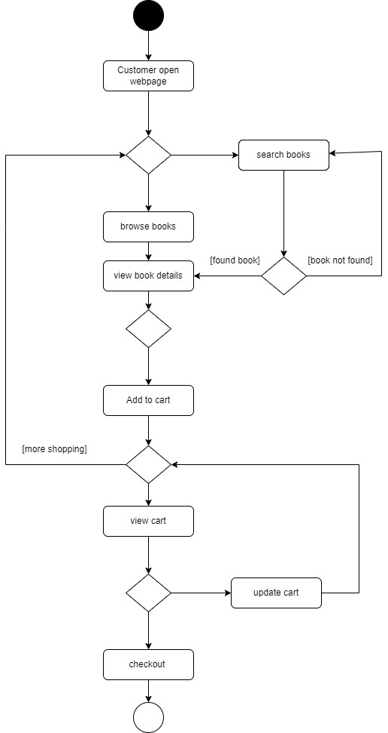

**13) Draw use case on online bill payment system (paytm).**

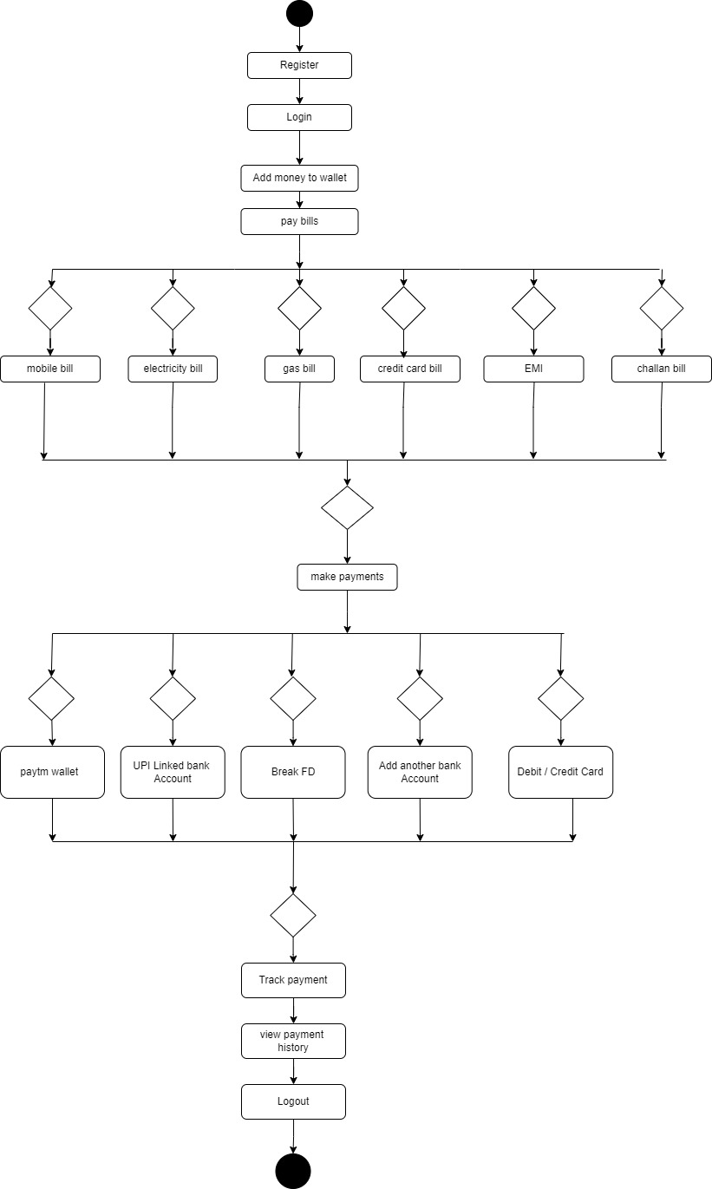

**14) Write SDLC phases with basic introduction.**

**SDLC phases:**

* Requirements Gathering**:** establish customer needs
* Analysis**:** model and specify the requirements-**what**
* Design**:** model and specify a solution-**why**
* Implementation**:** construct a solution in software.
* Testing**:** validate the solution against the requirements.
* Maintenance**:** repair defects and adapt the solution to the new requirements.

**15) Explain phases of the waterfall model.**

The waterfall model has six phases which are:

**1.Requirements:** The first phase involves gathering requirements from stakeholders.

**2. Analysis:** Analyzing these requirements to understand the scope and objectives of the project.

**3. Design:** Once the requirements are understood, the design phase begins. The design team can now expand the information established in the requirement document.

**4. Implementation:** The implementation phase involves coding the software based on the design specifications.

**5. Testing:** In the testing phase, the software is tested as a whole to ensure that it meets the requirements and is free from defects.

**6. Maintenance:** The final phase of the waterfall model is maintenance, which involves fixing any issues that arise after the software has been deployed.

**16) Write phases of spiral model.**

The spiral model is very widely used in the software industry. It consists of the following phases:

1. **Planning:** The first phase of the spiral model is the planning phase, where the scope of the project is determined and a plan is created for the next iteration of the spiral.
2. **Risk analysis:** In the risk analysis phase, the risk associated with the project are identified and evaluated.
3. **Engineering:** In the engineering phase, the software is developed based on the requirements gathered in the previous iteration.
4. **Customer Evaluation:** In the phase, assessment of the results of engineering.

**17)Explain working methodology of agile model and also write pros and cons.**

* Agile SDLC model is a combination of iterative and incremental model.
* There is a no deadlines for projects.
* There are no fixed requirements and you can change it anytime.
* Customer satisfaction by rapid delivery of working software product.
* At the and of the iteration a working product is displayed to the customer and important stakeholders.

**Pros**

* A very realistic approach to software development.
* Promotes teamwork and cross training.
* Suitable for fixed or changing requirements.
* Delivers early partial working solutions.
* Little or no planning required.
* Easy to manage.
* Gives flexibility to developers.

**Cons**

* Not suitable for handling complex dependencies.
* More risk of sustainability, maintainability and extensibility.
* There is very high individual dependency, since there is minimum documentation generated.
* Transfer of technology to new team members may be quite challenging due to lack of documentation.

**18) Draw use case on online shopping product using COD**

**19) Draw use case on online shopping product using payment gateway.**